Angelos Michalopoulos
Artificial intelligence principals
15/7/2025

Question 2: Prediction Task Report

For the second question of the final project, I had to evaluate a classification model for a medical dataset that is supposed to be able to predict a patient’s disease (the classes) based on the patient’s symptoms. The dataset, which is the dermatological dataset from UC Irvine machine learning repository. The dataset has 35 features 34 of which are the inputs the determine the class of the row (which is the 35th feature and it is separated into 6 classes). Out of the 34 features 33 of them (the symptoms) are linear valued while one of them is nominal which is the family history attribute that is binary with values of 0 or 1. The first thing that I had to do for the project was the preprocessing of the data so I can get the best possible outcome of the model. In order to start the preprocessing of the data start with importing the dataset and then visualizing the table using the head() function and its shape using the .shape function. 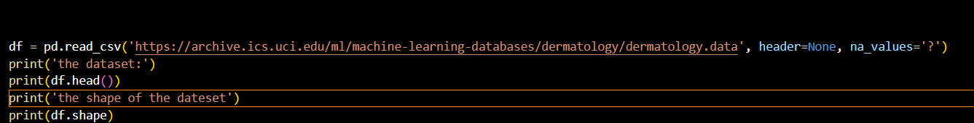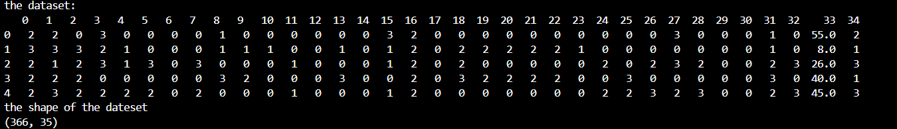
This way I can see how the dataset is formatted and how it is shaped, which means it size of rows and columns which in this chase it is 366 rows and 35 columns. The next thing I did for the preprocessing is seeing the number of unique and missing values per collum, which can tell me how usable the features are usable. 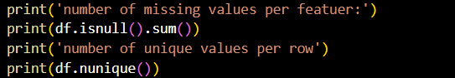

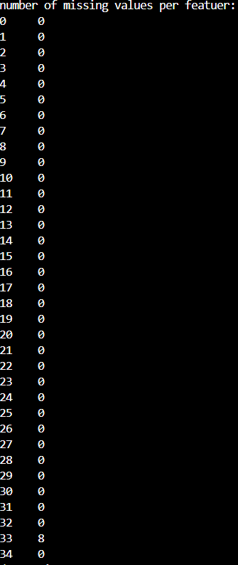
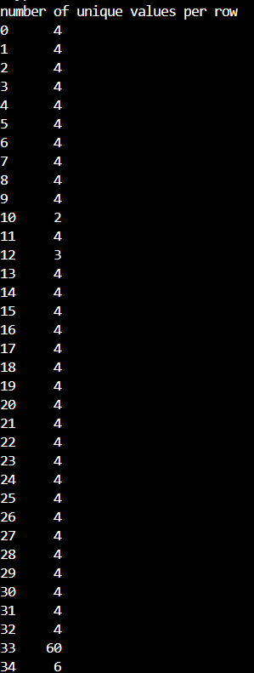
The number of unique values shows that There isn't a feature that has 0 unique values and since the values of most of the features (with exception of the age feature and the family history feature) the values that the features get or 0,1,2,3 so that’s shows in the output, for the missing values we see that with the exception of the age feature, which has 8 missing values, no collum has a missing value which shows that the dataset is when informed and usable. Moving on I check to see if the dataset has any duplicate values and its if any featuers have to low of a variance in their values 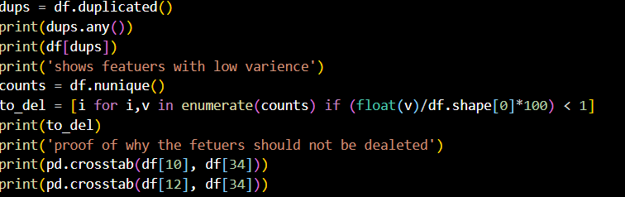
The output shows that the are no duplicates and the low variance if ether because the feature is binary (family history) or it is very class oriented and we can remove it because it might be important in order to differentiate that class from the rest. Thye lasting I did for the preproccesing was haldeing the missing values. Which since class besde midian imputesion will itroduse data leakage I n the model I am using and since the missing values are 2.2% of the tola rows, which since the crambrige post if it is less than 5% it will not affect the final model I will remove the features as long as they are inded missing at ramdon and which means that it indid doesn’t affct the model, 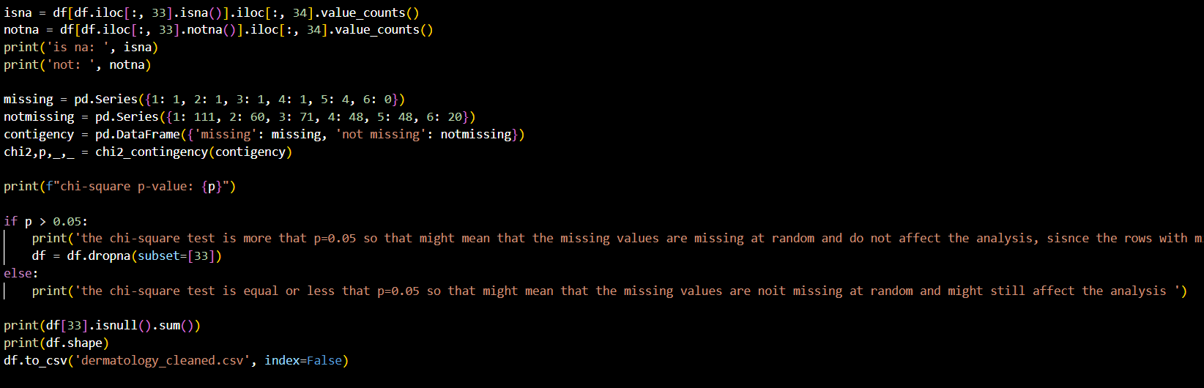
This code, which shows the class distribution of the missing values and then uses those tables to calculate the chi-square value shows that the values are Indeed missing and so the values are removed.
For the model I used the Weka model, which ius one of the suggested models to use. Before I started, I sued a filter to turn the class feature from numerical to nominal as is required for Weka classification problems and for the model I used the Multilayer perceptron and the evaluation method of cross validation with 10 folds. I started with the default parameters of Weka with initial seam to provide a very good accuracy, 97.486% and only 9 wrong answers but with further investigation it shows signs of overfitting, since when I use the “use training set” test option it shows an 100% accuracy which shows that the model right now memorizes perfectly and doesn’t generalize, that means parameter tuning had to be inducted. After multiple experiments I found that the best parameters are the following: MultilayerPerceptron -L 0.01 -M 0.25 -N 500 -V 0 -S 0 -E 20 -H i
the reason for those parameters are, for the learning rate (L), the momentum (M) and the number of epochs (N) and threshold for number of consecutive errors (E) changing them would negatively influence the accuracy by lowering the accuracy or if the it when higher it would show sing of overfitting or it the accuracy would not change where in those instances I would choose the least complex parameter so that the model had less chances of overfitting. For example, when it increased the learning rate from 0.01 to 0.02 while the cross-validation accuracy didn’t change the train set accuracy was 100 which is a sign of overfitting. For the number of hidden layers, as well as the number of nodes per layer I chose 1 hidden layer, that is because if I increase the number of layers the accuracy would fall to under the 90% acuurasy and for the number of nodes the to best are a (which is 17 nodes) and i (which is 34 nodes) while i is more complex than a I chose it because it has a slightly better accuracy (10 wring answers to a’s 11) and the training accuracy is close relative to a’s training accuracy so that means less chances of overfitting. The results after the hyperparameter tuning is as such.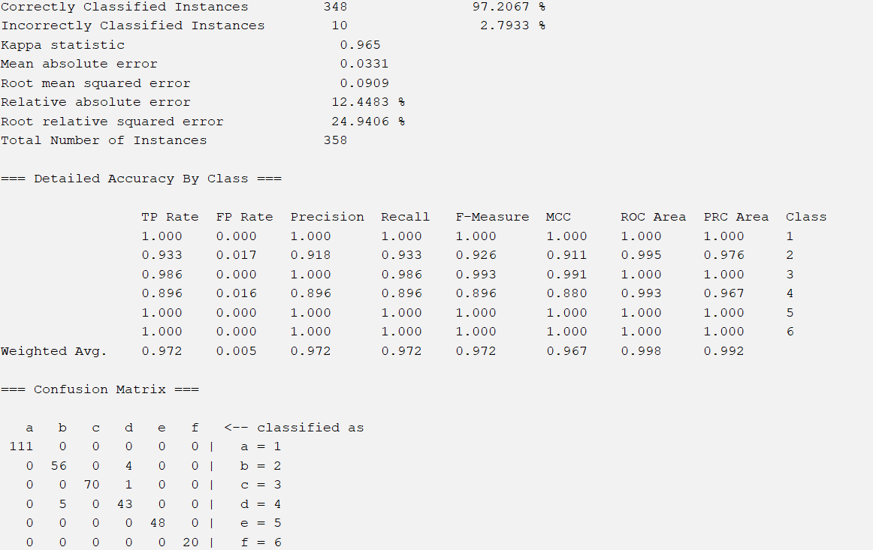
From the screenshot above we can see the recall (which measures how well the model identifies all actual instances of each class), precision (which shows the rate of true positives based on all the selected predictions) for the model, we can see from the weighted average (the average of these metrics but weighted for the classes) all of them are very good, all of them being 0.97 and above. The only classes that showed a real problem are the second and fourth classes with had the lowest recall and precision, 0.918 and 0.896 for the precision and 0.933 and 0.896 for the recall of these classes, those is also show in the confusion matrix which shows that the model has a difficult time separating those two classes from each other since all of there wring inputs are for the other class and are 9 of the 10 wrong answers (only the third class also didn’t has all the correct prediction which is show as it it is the only class also didn’t have 100% on the recall.

